ENTRY METHOD: FIRST RECEIVED
ENTRIES WILL OPEN ON Monday, March 2, 2015 at 8:00 AM at the Trial Secretary’s address with preference to Miniature American Shepherds (see page 4). All entries received before this date will be returned. Overnight or certified mail must be sent with the “No Signature Required” waiver signed.
ENTRIES CLOSE ON Friday, May 1, 2015 at 10:00 PM after which time entries cannot be accepted, cancelled, altered, or substituted except as provided for in Chapter 11, Section 6 of the Rules Applying to Dog Shows. Envelopes/transactions containing entries for more than the ten (10) dog maximum and/or entries received prior to the opening date shall be treated as an invalid entry and shall be returned to the sender.

PREMIUM LIST
AKC All-Breed AGILITY TRIALS
Event # 20157019010, 2015701911

This Event is Accepting Entries for All American Dogs
Listed in the AKC Canine Partners Program SM

Miniature American Shepherd Club of the United States
(Licensed by the American Kennel Club)
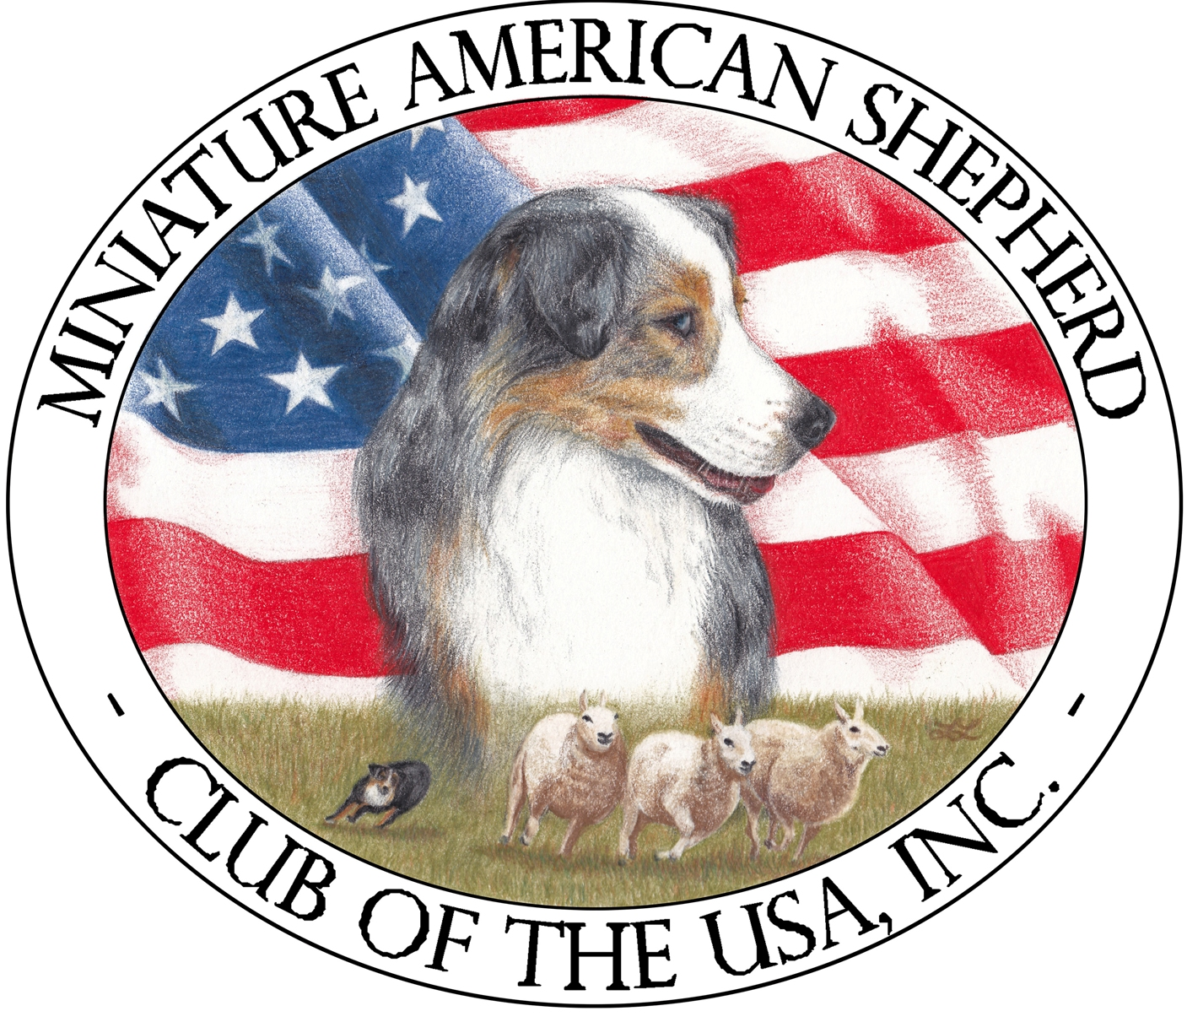
May 16, 2015
May 17, 2015

K-9 Manners and More
1000 E Memphis Street, Broken Arrow, OK 74012

ENTRY LIMITS
Saturday & Sunday – 300 runs per day
Indoors: Rubber Agility Matting: Size of Ring
Ring size is 80’ X 120’
Trial Hours:
Saturday 7:30am to 7:00pm
Sunday – 7:00am to 7:00pm
Judge
Pamela Nettles, 17485 S County Road 202, Elmer, OK 75359


CERTIFICATION
Permission is granted by the American Kennel Club for the holding
of this event under American Kennel Club rules and regulations.
James P. Crowley, Secretary

Officers of the AMERICAN MINIATURE SHEPHERD CLUB OF THE US

President ……………….. Karen Keller------ 80 Bobcat Springs Rd, Buellton, CA 93427
Vice President ………….. Judy Challinger------------------- PO Box 140, Vina, CA 96092
Secretary ……………….. Linda DuBois-------------2029 Wells Ct, Allentown, PA 18103
Treasurer ………………. Patricia Davis-----------18603 13th Street, Shawnee, OK 74801

Board of Directors

Sue Fontaine, Ellen Friedman, Sue Ritter

Trial Chairperson | Trial Secretary
Mindy Stevenson  27560 East 77th St S.,  Broken Arrow, OK 74014  (918) 557-2349  mshorse@windstream.net | Barbara Jeleski  9043 E 29th St  Tulsa, OK 74129-6803  (918) 625-5874  agilitymom@sbcglobal.net

Event Committee

Mindy Stevenson, Karen Cooper
Jeanie McAdams, Laurie Morris & Mary Green
(and/or any MASCUSA or MAMASC members present)

Judges and Assignments
Saturday  Pamela (Candy) Nettles | Sunday  Pamela (Candy) Nettles
All Standard, JWW & T2B Classes | All Standard, JWW & T2B Classes

Veterinarian on Call (or In Attendance)

Jennifer Patton, DVM, Advanced Care Veterinary Hospital
12226 Heywood Hill Road
Sapulpa, OK 74066
(918) 224-1900
Exhibitors should follow their veterinarian’s recommendations to assure their dogs are free of internal
and external parasites, any communicable diseases, and have appropriate vaccinations.

Emergency Services

St John’s Hospital, 1000 W Boise Cir, Broken Arrow, OK 74012
(918) 994-8000 (Directions to the hospital will be available on site)
Fire Department and EMSA – (918) 259-8660
Police Department – (918) 451-8844

Classes Offered & judging times

SATURDAY |  | SUNDAY
Standard | Jumpers with Weaves | Standard | Jumpers with Weaves
Master & Master P | Master & Master P | Master & Master P | Master & Master P
Excellent & Excellent P | Excellent & Excellent P | Excellent & Excellent P | Excellent & Excellent P
Open & Open P | Open & Open P | Open & Open P | Open & Open P
Novice A, B, P | Novice A, B, P | Novice A,B, P | Novice A,B, P
Time 2 Beat | Time 2 Beat Preferred | Time 2 Beat | Time 2 Beat Preferred
Self-check in at 7:30 am |  | Self-check in at 7:00 am
Judging begins no earlier than 8:30 am  Running Order & Start time will be in the  Judging Program |  | Judging begins no earlier than 8 am  Running Order & Start time will be in the  Judging Program

Please consult the AKC Regulations for Agility Trials for a complete description and eligibility for entry into these classes. The exhibitor is fully responsible for entering the dog in the correct class(es)/height divisions. Dogs running in a lower height division than they are eligible for will be eliminated.
Height Divisions

Regular | Preferred | Height at Withers
Handlers may opt to run their dog in a higher height division. | Handlers must run their dog in their proper eligible height. | Owners are responsible for entering their dog in the proper height division.
8” 8” | 4” | For dogs 11 inches and under at the withers
12” | 8” | For dogs 14 inches and under at the withers
16” | 12” | For dogs 18 inches and under at the withers
20” | 16” | For dogs 22 inches and under at the withers
24” | 20” | For dogs over 22 inches at the withers
26” | n/a | Dogs may be entered at this height at their owner’s discretion

MEASURING and HEIGHT CARD INFORMATION
Effective January 1, 2010, exhibitors are no longer required to provide proof to Trial Secretaries
that their dog has a valid jump height card as part of the check-in process. Furthermore, this
change eliminates the need for a copy of the jump height card to be submitted with an entry form. Dogs without a valid Jump Height Card/Form may still compete; but they must be measured/wicketed by the Judge of Record PRIOR to running in their class and this measurement will be valid for that weekend of trials only. The exception to this requirement is a dog entered in the 24” or 26” height division. However, if a Volunteer Measuring Official (VMO) or an Agility Field Rep is present; ALL dogs without a valid Jump Height Card/Form must be measured at some time during the trial or cluster of trials. This does not preclude having the dog wicketed by the Judge of Record if the VMO or Rep is not available to measure the dog before its first run of the trial or cluster of trials. It is the exhibitor’s responsibility to have their dog measured prior to running and failure to do so will result in the cancellation of any qualifying scores.

NEW Simplified Jump Height Card Process
When filling out the entry form, there is a new section at the top of the form for exhibitors to
designate whether your dog needs to be officially measured. Please check the box so that the Trial Secretary knows whether to include your dog on the Dogs To Be Measured List. It is no longer required that you submit a copy of your dog’s jump height card with your entry form or show it during day of show check-in.

Dog Eligible to Enter

This trial is open to all dogs fifteen (15) months of age or older that are registered with the American Kennel Club or that have AKC Limited Registration, Purebred Alternative Listing/Indefinite Listing Privileges (PAL/ILP), an AKC Canine Partners listing number, or approved Foundation Stock Service (FSS) breeds are eligible to participate.

Dogs with a Purebred Alternative Listing/Indefinite Listing Privileges (PAL/ILP) or an AKC Canine Partners listing number must be spayed or neutered in order to compete. Wherever the word “dog” is used in these regulations it includes both sexes.

Dogs should be physically sound. Dogs that are blind or deaf shall not be eligible, and neither are bitches in season, aggressive dogs, or dogs suffering from any deformity, injury, or illness which may affect the dog’s physical or mental performance. No dog shall compete if it is taped or bandaged in any way or has anything attached to it for medical purposes. Refer to Chapter 2 of the Registration and Discipline Rules for the listing of registerable breeds that may participate. Puppies under four (4) months of age are strictly prohibited from the trial grounds.

Obstacles and Ring Conditions

Obstacles will meet the specifications for obstacles in the current edition of the Regulations for Agility Trials. All classes will take place indoors on an agility rubber matted surface. Ring size will be 80’ X 120’. Contacts and table are rubberized surface.

Entry Fees per day

First entry of each dog (includes a $3.50 AKC recording fee)……...………… $23.00
Second entry of same dog (includes a $3.00 AKC recording fee)…………. $13.00
Third entry of same dog (includes a $3.00 AKC recording fee) …………….. $13.00

ENTRY METHOD: First Received with preference for Miniature American Shepherds. All entries will be accepted on the opening date, but only entries for Miniature American Shepherds will be entered into the trial for the first week. All other entries will be put on a combined waiting list. On March 9, 2015 those entries will be entered in the trial in the order received regardless of method until the trial limits are reached. Entries received on or after March 9. 2015 will be entered in the trial in order of receipt regardless of breed until the trial limits are reached.
If you would like to know the status of your entry prior to the issuance of the judging schedule upon closing, please enclose a self-addressed, stamped envelope or postcard along with your entry. E-mail confirmations will be sent to those listing a legible e-mail address on the entry form.
Mail entry forms and fees to: Barbara Jeleski, Trial Secretary, 9043 E 29th St,, Tulsa, OK 74129-6803. Please make checks payable to: MAMASC. No entries will be accepted by phone or fax. No hand deliveries will be accepted in the first twenty-four hours following the opening date and time. Express mail entries must include the signature waiver allowing them to be left at the secretary’s address. Inquiries may be directed to Barbara Jeleski at agilitymom@sbcglobal.net. No entry shall be made and no entry shall be accepted which specifies any conditions as to its acceptance.
Illegible entries will not be processed and will be returned to the exhibitor. Returned checks do not constitute a valid entry and the Trial Secretary will add a [$25] collection fee (optional) to the amount of each returned check.

MOVE UPS will be accepted for the trial until Monday, May 11, 2015 at 6 PM. Please submit in writing (e-mail is fine) to Barbara Jeleski at agilitymom@sbcglobal.net . Move Up is not confirmed until exhibitor receives a return confirmation from the trial secretary. Entries must be made on Official AKC entry forms or copies and must include the signed Agreement and Rules.
Junior Handlers must enter their JH# and complete back of form. Include only AKC titles on entries.
“After Closing” Waiting List
A waiting list (30 run maximum each day) will be maintained for these trials once they have closed on May 1, 2015. The waiting list will be active until its deadline — Monday, May 11, 2015 at 6:00 pm CDT. Any dogs that are entered in these trials at closing and pulled before the waiting list deadline will be replaced, if possible, by dogs in order on the waiting list, and the exhibitor will be reimbursed in full. If a dog is pulled but cannot be replaced, the exhibitor will not receive a refund and the dog will be considered absent for the trials. Entry fees for dogs on the waiting list that do not get into the trial by the waiting list closing date will be refunded in full.

Course WALK-THROUGHS AND Warm-Up INFORMATION

Handlers in all classes are permitted to walk the course, without a dog, during a walk-through period held prior to the start of the class. The walk-through is restricted to handlers entered in that class only. Handlers with multiple dogs, at events with multiple rings may request to walk with a height group other than the one their dog is entered in if a conflict is imminent.

A warm-up area, consisting of a regulation agility jump, may be provided for exhibitors. The warm-up area is to be used exclusively for warming up the dog and not for training or relieving of the dog.

Ribbons, Awards, and Prizes

Ribbons will be awarded in each jump height division in each class as follows:
First Place……………………………………...……………...……………………….……….…..Blue
Second Place……………...……………………..…………………………………………………Red
Third Place……………………………………..…………………………………...……………Yellow
Fourth Place………………………………………………......…………………………..………White
Qualifying Score……………………………………………………..……………...…..…Dark Green

Ribbons will be awarded to the 1st through 4th place dogs in each Standard and JWW class, and 1st place in each T2B jump height per AKC rules. Qualifying ribbons will be awarded to dogs receiving qualifying score. Dogs must qualify to receive a placement ribbon. New Title rosettes will be available for new titles earned at this trial. Double Q and QQQ ribbons will be awarded. Special MACH and PACH Rosettes, along with a MACH/PACH pole will be available for dogs earning those titles at this trial.

High In Trial Award for Miniature American Shepherd: Wooden Engraved Key Holder
High In Trial Rosette for Miniature American Shepherd

Awarded to the dog/handler team earning a Double Q in Standard
and Jumpers with Weaves with the highest combined YPS (Yards Per Second). If there is no Double Q; the dog with highest YPS, will earn the award. In case of a tie: the dog with the highest YPS in Standard (Preferred) is the winner.

All exhibitors should obtain a copy of the Regulations for Agility Trials by downloading them from the American Kennel Club website at http://www.akc.org/rules/.

NOTICE TO EXHIBITORS

SAFETY, BEHAVIOR and LIABILITY
The safety of the dog is our primary concern. By entering this trial, exhibitors acknowledge that they are familiar with the rules and regulations of this sport, and that their dogs are familiar with and able to perform all obstacles safely.
It is expressly understood that exhibitors alone are responsible for the behavior of their dogs and/or children. Any exhibitor whose dogs and/or children create an unnecessary disturbance or repeatedly engage in unsafe or disruptive behavior may, at the discretion of the trial committee, be asked to leave the show site. In such case, no refund of any fees paid will be made. The [MASCUSA] and its agents, employees, etc., will assume no responsibilities for any loss, damage or injury sustained by exhibitors or handlers, or to any of their dogs or property and further assumes no responsibility for injury to children. The MASCUSA reserves the right to decline entries for cause and may remove any dog on account of aggression. No one shall have any recourse or claim against the [MASCUSA] or any official thereof.
All dogs must be on leash at all times when on trial grounds except when in the designated warm-up area or competing on the course.

REFUNDS
No entry fee will be refunded if the trial cannot open or be completed by reason of riots, civil disturbances, fire, an act of God, public emergency, act of a public enemy, or any other cause beyond the control of the organizing committee. No entry fee will be refunded in the event a dog is absent, disqualified, excused, or barred from competition by the action of the Trial Committee.
Bitches in season are not permitted to compete in Agility Trials. As such, the club will refund [100%] per day of the entry fee paid for bitches unable to compete for this reason upon presentation of a veterinarian certificate e. This certificate must be presented to the Trial Secretary prior to the start of judging on the first day of the trial or cluster of trials.

RINGSIDE
Dogs may arrive any time prior to judging if the dog has a valid temporary or permanent jump height card. Otherwise, they must be available for measuring prior to the start of their class if a VMO or AKC Field Rep is available to measure dogs. All dogs not needed for further judging will be excused.
Judges are not required to wait for dogs. The Owner of each dog is solely responsible for having it ready at ringside when it is to be judged. The Club has no responsibility for providing service through a public address system or stewards or runners for the purpose of calling or locating dogs that are not brought into the ring when required.

VENDORS: K9 Manners and More Retail Store located inside the facility

This club does not agree to arbitrate claims as set forth on the Official AKC Entry Form for this event.

Additional Site Information

CRATING SPACE will be available on a limited basis. Crates may be left overnight; however, the MASCUSA and the K9 Manners & More will not be responsible for any lost or damaged items left at the show site.
Food & snacks will be available on the site for purchase. There are various restaurants and fast food vendors within a very short driving distance.
No overnight parking will be allowed at the trial site. No electrical hook-ups for motor homes or campers are available. RV’s are discouraged due to space limitations.
Exhibitors are responsible for cleaning up after their dog(s). Any exhibitor failing to do so may be excused without benefit of refund if the Trial Committee deems the exhibitor to be in violation of this requirement. Cleaning supplies and disposal sites will be available at various locations around the show grounds.

Hotel Information

These hotels have graciously agreed to accept our well-mannered dogs. A pet deposit may be required. Please check with hotels for policies and restrictions.

Hotels and Motels that will accept dogs
Please act responsibly! Keep your pets in crates at motels. Do not bathe or groom dogs in motel rooms. Use heavy plastic under crates. Motels reserve the right to change their pet policy at any time

Clarion Hotel….…………………………………………..…………(918) 258-7085
2600 N. Aspen , Broken Arrow, OK, US, 74012, Phone: (918) 258-7085 Fax: (918) 251-6768 http://www.clarionoftulsa.com Email: gm.ok161@choicehotels.com
Located on the Aspen exit (145th East Ave.) off the BA Expressway (Hwy. 51), on the southwest corner of the BA Expressway and Aspen Ave.
Directions to the Trial Site



For a detailed map please visit www.k9-manners.com

Directions: K9 Manners & More training center is at 1000 E Memphis, Broken Arrow, OK 74012.
This is on the northeast corner of Lynn Lane & Memphis. From the Broken Arrow Expressway (highway 51) take the Lynn Lane exit and go south 2 miles. Cross the railroad tracks just south of 81st street and turn left.
FYI: Lynn Lane is also called 177th, 9th and 23rd street (hey… it’s a Broken Arrow thing)

This trial is supported by Mid America Miniature American Shepherd Club (MAMASC) a MASCUSA Affiliate http://mamasc.com

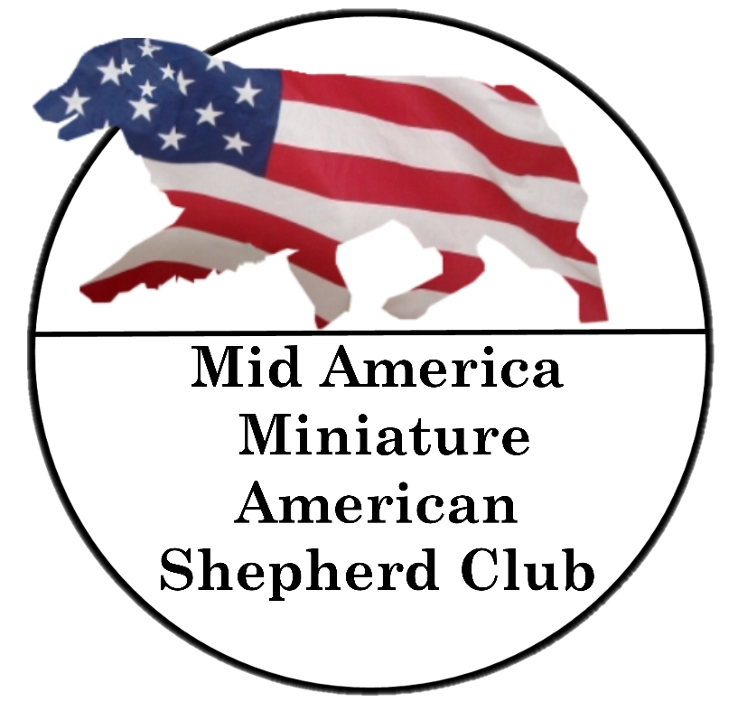

AGILITY TRIAL MOVE-UP FORM
(Do not send this form to AKC. Send it to the Trial Secretary)

USE THIS FORM TO MOVE UP TO A HIGHER AGILITY CLASS ONLY

It is the option of the club to allow day-to-day move-ups. Exhibitors should refer to a club’s premium list to verify the club’s policy for moving a dog up. If offered, dogs shall be moved up to a higher class at the request of the owner, as a result of the dog qualifying for an agility title.

The request for moving up must be made to the Trial Secretary according to the club’s published policy. All move-up entries are subject to availability of the class and payment of any difference in entry fee. Dogs so moved-up will be entered at the end of the running order. Refer to Chapter 1, Section 20 of the Regulations for Agility Trials for additional move-up requirements.

Name of Club Date

Breed Sex

Dog’s AKC Name Dog’s AKC #

Move Entry to:
Agility Class: (Circle One) Jump Height Division: (Circle One)

Regular Standard | Open | Excellent | Master | 8” | 12” | 16” | 20” | 24” | 26”
Regular JWW | Open | Excellent | Master | 8” | 12” | 16” | 20” | 24” | 26”
Regular FAST | Open | Excellent | Master | 8” | 12” | 16” | 20” | 24” | 26”
Preferred Standard | Open | Excellent | Master | 4” | 8” | 12” | 16” | 20”
Preferred JWW | Open | Excellent | Master | 4” | 8” | 12” | 16” | 20”
Preferred FAST | Open | Excellent | Master | 4” | 8” | 12” | 16” | 20”

Owners Name:

Handlers Name:
(If applicable)

Signature of owner or agent
duly authorized to make this entry:

Signature of Trial Secretary
If Approved: Date:

Time Received:

OFFICIAL AMERICAN KENNEL CLUB AGILITY ENTRY FORM
MINIATURE AMERICAN SHEPHERD CLUB OF THE UNITED STATES
Opens: Monday, March 2, 2015 at 8 AM ● Closes: Friday, May 1,2015 at 10 PM
Day 1: Saturday 5/16/15 | □ STD | □ JWW |  |  |  | □T2B
Day 2: Sunday 5/17/15 | □ STD | □ JWW |  |  |  | □ T2B
DAILY ENTRY FEE: 1st run $23.00; $13 each additional run
Make checks payable to: MAMASC; Mail to: Barbara Jeleski, 9043 E 29th St., Tulsa, OK 74129-6803
IMPORTANT: Carefully read instructions before filling out! ENTRY FEE ENCLOSED

Choose Either Regular OR Preferred Classes
Circle one jump height, and circle class selections :: Only one selection per class (STD, JWW, FAST, T2B)
REGULAR Classes  8” 12” 16” 20” 24” 26”  STD Nov A Nov B Open Exc Master  JWW Nov A Nov B Open Exc Master  FAST Nov A Nov B Open Exc Master  T2B T2B |  |  |  | PREFERRED Classes  4” 8” 12” 16” 20”  STD NovP OpenP ExcP MasterP  JWW NovP OpenP ExcP MasterP  FAST NovP OpenP ExcP MasterP  T2B T2BP
This Dog Needs To Be Measured □Yes □No |  |  | SEX |  |  |  | HEIGHT AT WITHERS
BREED |  |  | VARIETY |  |  |  | CALL NAME
AKC® NAME (INCLUDE AKC TITLES ONLY)
AKC® NO □ Enter Complete Registration # below  ILP NO. □ PAL NO. □  FOREIGN REG. NO & COUNTRY □ |  |  |  |  | DATE OF BIRTH
 |  |  |  |  | PLACE OF BIRTH (LIST COUNTRY)
BREEDER
SIRE
DAM
ACTUAL OWNERS
OWNERS ADDRESS  new address
CITY, STATE ZIP + 4
HANDLER ENTER JR. HANDLER # if applicable
Exhibitor or owner MUST sign on the signature line beneath the instructions.
AKC Rules, Regulations, Policies and Guidelines are available on the American Kennel Club Web site, www.akc.org.
AGREEMENT
I (we) agree that the club holding this event has the right to refuse entry for cause which the club shall deem sufficient. In consideration of the acceptance of this entry and of the holding of this event and of the opportunity to have the dog judged and to win prizes, ribbons, or trophies, I (we) agree to hold the AKC, the event-giving club, their members, directors, governors, officers, agents, superintendents or event secretary and the owner and/or lessor of the premises and any provider of services that are necessary to hold this event and any employees or volunteers of the aforementioned parties, and any AKC approved judge, judging at this event, harmless from any claim for loss or injury which may be alleged to have been caused directly or indirectly to any person or thing by the act of this dog while in or about the event premises or grounds or near any entrance thereto, and I (we) personally assume all responsibility and liability for any such claim; and I (we) further agree to hold the aforementioned parties harmless from any claim for loss, injury or damage to this dog.
Additionally, I (we) hereby assume the sole responsibility for and agree to indemnify, defend, and save the aforementioned parties harmless from any and all loss and expense (including legal fees) by reason of the liability imposed by law upon any of the aforementioned parties for damage because of bodily injuries, including death at any time resulting therefrom, sustained by any person or persons, including myself (ourselves), or on account of damage to property, arising out of or in consequence of my (our) participation in this event, however such, injuries, death or property damage may be caused, and whether or not the same may have been caused or may be alleged to have been caused by negligence of the aforementioned parties or any of their employees or agents, or any other persons.
I (WE) AGREE THAT ANY CAUSE OF ACTION, CONTROVERSY OR CLAIM ARISING OUT OF OR RELATED TO THE ENTRY, EXHIBITION OR ATTENDANCE AT THE EVENT BETWEEN THE AKC AND THE EVENT-GIVING CLUB (UNLESS OTHERWISE STATED IN ITS PREMIUM LIST) AND MYSELF (OURSELVES) OR AS TO THE CONSTRUCTION, INTREPRETATION AND EFFECT OF THIS AGREEMENT SHALL BE SETTLED BY ARBITRATION PURSUANT TO THE APPLICABLE RULES OF THE AMERICAN ARBITRATION ASSOCIATION. HOWEVER, PRIOR TO ARBITRATION ALL APPLICABLE AKC BYLAWS, RULES, REGULATIONS AND PROCEDURES MUST FIRST BE FOLLOWED AS SET FORTH IN THE AKC CHARTER AND BYLAWS, RULES, REGULATIONS, PUBLISHED POLICIES AND GUIDELINES.
INSTRUCTIONS
Handlers may opt to enter in a higher height division for all Regular titling classes, but not in a division lower than their proper height division. Dogs entered in the Preferred classes must compete at the required jump height and may not compete in a jump height division higher or lower than their proper height division.
All dogs that have not been officially measured for an Agility Jump Height Card may still compete; however, they must be measured by a Judge of record, an Agility Field Representative, or a Volunteer Measuring Official, prior to running. If measured by the Judge of record, that measurement will be valid for this trial or back-to-back trials only. If a measurement is necessary, it is the exhibitor's responsibility to have their dog(s) measured prior to running.
Dogs listed in the AKC Canine PartnersSM program may be eligible to enter all-breed AKC agility trials at the club’s option. These dogs should be listed as All American Dog and must include their AKC number on the entry form and check the AKC No. box.
Junior Handlers should enter their Junior Handler number on the front of this form. Should you not have your Junior Handler number, it may be obtained from the American Kennel Club (919) 233-9767. If the Junior Handler is not the owner of the dog identified on the face of this form, what is the relationship of the Junior Handler to the Owner?

I CERTIFY that I am the actual owner of the dog, or that I am the duly authorized agent of the actual owner whose name I have entered above. In consideration of the acceptance of this entry, I (we) agree to abide by the rules and regulations of the American Kennel Club in effect at the time of this event, and by any additional rules and regulations appearing in the premium list for this event, and further agree to be bound by the “Agreement” printed on the reverse side of this entry form. I (we) certify and represent that the dog entered is not a hazard to persons or other dogs. This entry is submitted for acceptance on the forgoing representation and agreement. I (we) agree to conduct myself (ourselves) in accordance with all such Rules and Regulations (including all provisions applying to discipline) and to abide by any decisions made in accord with them.
SIGNATURE of owner or his agent duly authorized to make this entry.
SIGN HERE X ______
Telephone Number:

Email Address:
□New Email
In Case of Emergency - Name: Phone #:
AEAGL2 (09/12)

