Catalog
AKC Licensed (All Breed) Herding Tests

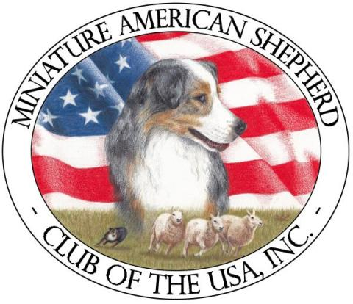
Miniature American Shepherd Club of the USA, Inc. (MASCUSA)
http://www.mascusa.org

One day of Herding Tests – Instinct, HT, PT

Sunday, June 9th, 2013 - AKC Event # 2013701901
Judge: Susan Abrams, AKC Judges # 45891
16300 W SIMMONS RD, EDMOND, OK 73025-9497

Herding Test and Pre-Trial Test: Sheep
Instinct Test: Sheep, Goats or Ducks at Judges’ Discretion

Event Site:
Latigo Farms, Melinda Stevenson
27560 E. 77th St S., Broken Arrow, OK 74014

Event Hours: 8:00 am to 5:00 pm or one hour after the conclusion of tests.
This event will be held outdoors regardless of weather.

LIMITED ENTRIES: 35 runs


AMERICAN KENNEL CLUB CERTIFICATION
Permission has been granted by the American Kennel Club for holding of these events under American Kennel Club rules and
regulations.
James P. Crowley, Secretary

TRIAL SECRETARY CERTIFICATION
I hereby certify to the correctness of the within marked awards and absentees as taken from the judge’s books.

Robin Provencher, Event Secretary

Miniature American Shepherd Club of the USA, Inc.
Officers and Directors

President …………….. Karen Keller------ 80 Bobcat Springs Rd, Buellton, CA 93427
Vice President ……….. Judy Challinger------------------- PO Box 140, Vina, CA 96092
Secretary …………….. Patricia Davis----------18603 13th Street, Shawnee, OK 74801
Treasurer ……………. .Traci Phillips---------- 173 Kings Row, Malakoff, TX 75148

Director Ellen Friedman
Director Sharon Sloper
Director Sue Fontaine

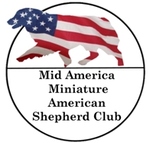
Supported by Mid America Miniature American Shepherd Club (MAMASC) a MASCUSA Affiliate http://mamasc.com

Event Committee
Trial Chair Melinda Stevenson, 27560 East 77th St. S., Broken Arrow, OK 74014
Course Director Khara Criswell
Chief Ring Steward Larry Baker
Chief Stock Livestock Handler Sally Thomas
Publicity, Awards and Hospitality Julie Voge
(and/or any MASCUSA or MAMASC members present)

Event Secretary
Robin Provencher, 4112 S. Birch Pl., Broken Arrow, OK 74011
Phone: (918) 978-3475 or E-mail: provencher3@windstream.net

EVENT HOURS
Will be 8:00 a.m. to 5:00 p.m., or one hour after conclusion of the tests.
Handlers Meeting will precede each class.

RIBBON PRIZE
Test Qualifying Score ……………………………………………….Dark Green

TROPHIES
Qualifying HT & PT scores will receive a fun herding themed magnet

CONCESSIONS
Grilled hotdogs & Snacks will be available on-site
Lunch break will be at the Judge’s discretion.

Judging Schedule

Sunday, June 9, 2013
Judge: Susan Abrams - AKC Judge’s # (45891)
Tests start at 8 a.m. and each class will follow the previous class in the order shown below.

Class | Stock | Running Order
Herding Instinct  Test | Goats, Sheep, or Ducks (at Judge’s discretion) | 117, 118,119, 120, 121, 122, 123, 124 | 8
Herding Trial Test | Sheep | 214, 215, 216, 217, 218, 219 | 6
Herding Pre Trial Test | Sheep | 304, 305, 306, 307, 308 | 5

Handlers meeting will precede each class.
Day of entries will be accepted for Instinct Testing Only

Stock Contractor
Mindy Stevenson

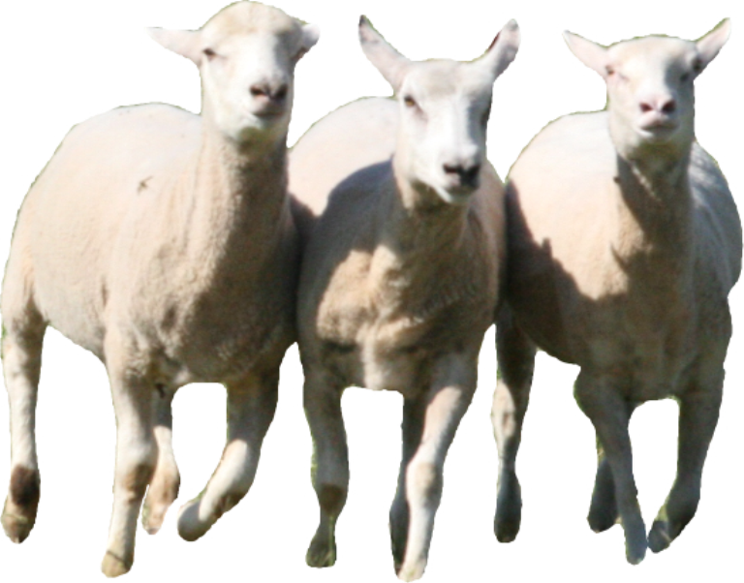

Sunday, June 9, 2013
Susan Abrams, AKC Judge’s # (45891)
Herding Instinct Test - Goats, Sheep or Ducks (at Judge’s discretion)

117  ABS  Score | Xtra! Xtra! V Temar, CDX, RE, GN- Havoc  DN22060201; German Shepherd; M; 06/04/07; Breeder: Mary Dygert; Sire: Xandro Vom Bauhofer-Land; Dam: Anastasija Van Noort; Owner: Kathleen Woodbury, 1808 Cardinal Ln, McAlester, OK 74501; Handler: Kathleen Woodbury
118  NQ  Score | Liesl Von der Burg Austerlitz – Liesl  DN27552906; German Shepherd; F; 04/12/10; Breeder: Susanne Shelton; Sire: Monti Vom Waldhang; Dam: May Von der Burg Austerlitz; Owner: Keli Harrell, PO Box 783, Sallisaw, OK 74955; Handler: Keli Harrell
119  Q  Score | Latigo Falina Eyes Black As Night - Falina  DN32600301; Miniature American Shepherd; F; 11-18-11; Breeder: Billy Fleming; Sire: Maximum Spontaneous Combustion; Dam: Patchwork’s Jean Gray the Marvel Girl; Owner: Billy Fleming, 27560 E. 77th St. S, Broken Arrow, OK 74014; Handler: Melinda Stevenson
120  Q  Score | Painted Meadow Red Hot Vegas, CGC - Vegas  DN33720501; Miniature American Shepherd; F; 11/07/10; Breeder: Linda K. Agan; Sire: Painted Meadow Blue; Dam: Mockingbirds Fancy Dancie Treasure; Owner: Linda K. Agan, 117 Knox Hwy 37, Galesburg, IL 61401; Handler: Linda K. Agan
121  Q  Score | Kayne Vom True Haus - Luke  DN35093001; German Shepherd; M; 10/14/12; Breeder: James Reed; Sire: Esko vom Klammeck; Dam: Terra vom True Haus; Owner: Shar Moore, 11650 Skyline Dr, Collinsville, OK 74021; Handler: Shar Moore

Move Ups
_________________________

Sunday, June 9, 2013
Event # 2013701901
Susan Abrams, AKC Judge’s # (45891)
Herding Instinct Test - Goats, Sheep or Ducks (at Judge’s discretion)

122  Q  Score | Rin Tin Tins Koko, CD GN RE OAP OJP - Koko  DN22880202; German Shepherd; F; 10/03/08; Breeder: Jan C Hall; Sire: CH Castle’s Gardalf; Dam: Rin Tin Tins Lady Solo Siren; Owner: Debra Hnath, 14705 E. Ridgeview Ln, Claremore, OK 74019; Handler: Debra Hnath
123  NQ  Score | Tidmores Rising Star Lydia, CGC - Mayhem  DN33657101; German Shepherd; F; 04/04/12; Breeder: Cynthia Tidmore; Sire: Arthos vom Hochstadter-Wappen; Dam: Tidmores Rising Star Beauty,CD,RE; Owner: Kathleen & Joseph Woodbury, 1808 Cardinal Ln, McAlester, OK 74501; Handler: Kathleen Woodbury

124  Q  Score | GCH CH Jbk Keppie’s Celtic Thunder – KJ  DN29774702; Border Collie; M; 09/02/10;  Breeder: Jodie Keener; Sire: Detania Kelsale Keppie; Dam: Shorelands Breakin The Rules; Owner: Robert W. & Nancy S. Harmon; 1325 Marion Anderson Road, Hot Springs, AR, 71913; Handler: Robert W. Harmon
 | Day of Entries Herding Instinct Test
125  Q  Score | Da Daisy Bells Perfect Poker Face – Daisy; WS37325105; Boxer OOwOwner - Cathy Love
126  Q  Score | ____Legacy let The Good Times Roll – Kade; Border Collie;  Ow DN229221/04; Owner; Bobbie Howell
127  Q  Score | Mov Winecup Boudin De Bien-Amie – Koda; Pyrenean Shepherd; perd;DN33096402; Owner; Teresa Ruedy

Sunday, June 9, 2013
Susan Abrams, AKC Judge’s # (45891)
Herding Test - Sheep

214  NQ  Score | Whistle-Stops Thrill of Victory - Vicki  DN30624801; Border Collie; F; 04-19-11; Breeder: Kathryne and Sheridan Williford; Sire: Younghaven’s Divine Intervention; Dam: Younghaven Walk the Wild Side; Owner: JoyceAnn Baker and Kathryne Williford, 20965 E. 36th Pl S, Broken Arrow, OK 74014; Handler: JoyceAnn Baker
215  Q  Score | Bordertown Chasing LLyr - Chase  DN33367205; Border Collie; M; 03/07/12; Breeder: Bordertown, Mary Green & Francis Scriminger; Sire: Bordertown Gee Wally; Dam: Bordertwon Enlighten Me; Owner: Laurie & Jessica Witt, 3909 S. 201st East Ave, Broken Arrow, OK 74014; Handler: Jessica Witt

216  Q  Score | Coopers Bailey Gal, CD BN RE NAP NJP CGC – Bailey  DN31864601; Miniature American Shepherd; F; 05/07/08; Breeder: Gary & Vicki Sorrells; Sire: Sorrells Tri Duke; Dam: Sorrells Ginger Girl; Owner: Karen Cooper, 2951 Silver Lake Rd, Bartlesville, OK 74006; Handler: Karen Cooper
217  Q  Score | Lord Jasper - Jasper  DN29132908; Border Collie; M; 11/10/10; Breeder: Michelle Weese; Sire: Y Uherdit My Hearts Desire, A.K.A "Desi; Dam: Lock-Eye Peck On The Cheek; Owner: GK Griffin, 2218 E. 59th St #2001, Tulsa, OK 74152; Handler: Melinda Stevenson
218  NQ  Score | Tidmores Rising Star Lydia, CGC - Mayhem  DN33657101; German Shepherd; F; 04/04/12; Breeder: Cynthia Tidmore; Sire: Arthos vom Hochstadter-Wappen; Dam: Tidmores Rising Star Beauty, CD,RE; Owner: Kathleen & Joseph Woodbury, 1808 Cardinal Ln, McAlester, OK 74501; Handler: Kathleen Woodbury
219  REM  Score | RB Wee Decorate My Life - Luke  DN16432001; Miniature American Shepherd; M; 12/25/06; Breeder: Roxana Bourassa; Sire: Rabbi Thered; Dam: Ms. Josie Girl; Owner: Melinda Stevenson, 27560 East 77th St. S., Broken Arrow, OK 74014; Handler: Melinda Stevenson
Move Ups
_________________________

Sunday, June 9, 2013
Event # 2013701901
Susan Abrams, AKC Judge’s # (45891)
Herding Pre-Trial Test - Sheep

304  Q  Score | Bellaclan Queen Of Hearts - Viva  DN29198804; Border Collie; F; 07/17/10; Breeder: Laura K S Shaw & Deanna Veselka; Sire: CH Wildblue Eternity; Dam: Kesca Pipers Sunset Melody; Owner: JoyceAnn Baker and Laura K S Shaw, 20965 E. 36th Pl S, Broken Arrow, OK 74014; Handler: JoyceAnn Baker
305  NQ  Score | GCH CH Jbk Keppie’s Celtic Thunder – KJ  DN29774702; Border Collie; M; 09/02/10;  Breeder: Jodie Keener; Sire: Detania Kelsale Keppie; Dam: Shorelands Breakin The Rules; Owner: Robert W. & Nancy S. Harmon; 1325 Marion Anderson Road, Hot Springs, AR, 71913; Handler: Robert W. Harmon
306  Q  Score | Bordertown Tri’d And True Blue – Truly  DN28259901; Border Collie; F; 06/05/10;  Breeder: Mary Green & Kimberly Sykes; Sire: CH Younghaven’s T’Ewe Hot At Bordertown, RN; Dam: CH Bordertown Ember Glow, CD,RE,PT; Owner: Mary Green & Kimberly Sykes, 309 S. Gum Ave., Broken Arrow, OK, 74012; Handler: Kimberly Sykes

307  Q  Score | CH Magdalyn Chub of Aston Clan, HT, CGC – Miss Moo  DN06209001; Border Collie; F; 02/25/04;  Breeder: Michael J. Aston; Sire: Chub, CD,NA, NAJ; Dam: Maggie Whye, CD; Owner: JoyceAnn Baker; 20965 E. 36th Pl S, Broken Arrow, OK 74014; Handler: JoyceAnn Baker
308  Q  Score | Maximum Spontaneous Combustion – Blast  DN31880101; Miniature American Shepherd; M; 12-14-06;  Breeder: Lauren Buth; Sire: Starstuff Ursa Major; Dam: Maximum Smiling Blue Angel; Owner: Melinda Stevenson, 27560 E 77th St. S, Broken Arrow, OK, 74014; Handler: Melinda Stevenson
Move Ups
_________________________

I certify that the above awards are in accord with the judging standard of Tests and Trial and that all
awards for placements and special awards are correct.
____________________________ | ______________________________ | _________________
Judge's Signature | Test or Class Judged | Date

Herding Eligible Breeds
All dogs 9 months of age or older from the following breeds are eligible to participate in Herding Events (Effective January 1, 2011 all dogs 6 months of age or older from the following breeds are eligible to participate in Herding Instinct Tests):.
AKC Recognized Breeds  Australian Cattle Dog  Australian Shepherd  Bearded Collie  Beauceron  Belgian Malinois  Belgian Sheepdog  Belgian Tervuren  Bernese Mountain Dog  Border Collie  Bouviers des Flandres  Boxers  Briard  Canaan Dog  Cardigan Welsh Corgi  Collie  Entlebucher Mountain Dog  Finnish Lapphund  German Shepherd Dog  Giant Schnauzer  Great Swiss Mountain Dog  Icelandic Sheepdog  Kerry Blue Terrier  Norwegian Buhund  Old English Sheepdog  Pembroke Welsh Corgi  Polish Lowland Sheepdog  Puli  Pyrenean Shepherd  Rottweiler  Samoyeds  Shetland Sheepdog  Soft Coated Wheaten Terrier  Standard Schnauzer  Swedish Vallhund | Foundation Stock Service Breeds Appenzeller Sennenhunde Belgian Laekenois Bergamasco  Berger Picard  Boerboel  Catahoula Leopard Dog Czechoslovakian Vlcaks Lancashire Heeler  Miniature American Shepherd  Mudi  Pumi  Spanish Water Dog Schapendoes  Slovensky Cuvac  Swedish Lapphund  NOTE: FSS Breeds may compete for suffix titles only.
- Dogs of these breeds recorded with the Purebred Alternative Listing Program/Indefinite Listing Privilege (PAL/ILP) or dogs with Conditional registration are eligible to participate.
- Spayed and neutered dogs are eligible to participate.
- Monorchid or cryptorchid males are eligible to participate.
- Bitches in season are eligible to participate.
- Lame, blind or deaf dogs may not participate.
- Dogs with Limited Registration are eligible to participate.

NOTICE TO EXHIBITORS

- A separate entry blank must be completed for each dog entered. Please use care in clearly indicating which days, classes, courses (A, B, Instinct, HT or PT) and stock you intend to enter for each dog.
- Bitches in season will be permitted to run, but will be moved to the end of the running order in Test Classes. Please notify the Event Secretary if your bitch is in season.
- Entry fees will be refunded to alternates who decline to be placed on the alternate list. Also, entry fees of alternates who do not participate in the test or trial will be refunded. Entry fees will not be refunded to a scheduled entrant who is absent on the day of the event unless an alternate is present and runs in the place of the absent dog.
- The MAMASC Treasurer will mail any and all refund checks after the event.
- Entry fees will not be refunded in the event that a dog is absent, disqualified, excused, or barred from competition by action of the Event Committee.
- It is expressly understood that exhibitors alone are responsible for the behavior of their dogs and/or children. Any exhibitor whose dogs and/or children create unnecessary disturbances or repeatedly engage in unsafe or disruptive behavior may, at the discretion of the Event Committee, be asked to leave the show site. In such case, no refund of any fees paid will be made.
- Owners or their Agents are solely responsible for the presence of their dog(s) at the Test or Trial arena. Judges are not required to wait for dogs.
- Exhibitors should follow their veterinarians’ recommendation to assure their dogs are free of internal and external parasites, any communicable diseases, and have appropriate vaccinations.
- No entry fee will be refunded if the event cannot open or be completed by reason of riots, civil disturbances, fire, act of God, public emergency, act of a public enemy, extreme weather conditions, or any other cause beyond the control of the event committee.
- No entry fee will be refunded in the case of duplicate entries or any other cause beyond the control of the club after the closing of entries.
- A tub for cooling-off will be provided.
- Please bring your own chairs.
- All dogs must be on leash at all times except when in the ring.
- No telephone, fax, online entries or credit card payments will be accepted. Returned checks do not constitute a valid entry fee. The MAMASC Treasurer will add a $20.00 collection to the amount of each returned check.
- No alcoholic beverages are allowed at the event site.
- Please respect the grounds and clean up after yourself and your dogs to maintain the premises in a clean and tidy condition!

Animal Aid
VETERINARIAN (OFF SITE)
Good Shepherd Veterinary Hospital
Dr. Kevin Long, DVM
1720 N. 9th, Broken Arrow, OK 74012
Phone (918) 893-3400 Cell (918) 893-3402
Directions to the Good Shepherd Veterinary Hospital:
North of the Broken Arrow Expressway on Lynn Lane
www.goodshepherdvets.com

People Aid
St John’s Hospital, 1000 W Boise Cir, Broken Arrow, OK 74012
(918) 994-8000
(Directions to the hospital will be available on site)
Fire Department and EMSA – (918) 259-8660
Police Department – (918) 451-8844

Disaster and Emergency Plans for People and Dogs at this Herding Event
Fire: Dial 911. All dogs should be crated or leashed securely. Owners, Handlers and Spectators must keep the main driveway clear so Emergency vehicles will have suitable access to the property.
Thunderstorms and Lightning: Should lightning be observed, all personnel and animals should move or be moved to the safety of their vehicles or covered buildings until the danger has passed.
Mass Disaster Plan – Tornado: In the event of a tornado, dogs should be leashed and all people and their dogs should proceed to the lowest point on the property until the danger has passed.
Personal Injury or Health Problems: Dial 911 for the Emergency Response Team/Ambulance, or see above. A First Aid Kit for minor injuries will be at the event site.
Dog Injuries: VETERINARIAN (OFF SITE) see above.

NOTES

