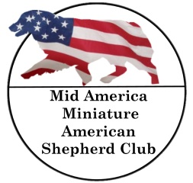
MID-AMERICA MINIATURE AMERICAN SHEPHERD CLUB
TOP-FIVE AWARD SUBMISSION FORM

DATE

OWNER NAME |  |  | MEMBERSHIP #
OWNER EMAIL
DOG’S REGISTERED NAME
DOG’S CALL NAME |  | DOG’S REG #
SIRE
DAM
BREEDER
HANDLER |  |  |  |  | JR? (Y/N)
WEB SITE:
SCORES ARE REQUIRED TO DETERMINE RANKINGS OF THE TOP 5 – AGILITY STANDARD RUNS ONLY
CODES FOR THE TYPE OF CLASS ARE LISTED BELOW – LINE 1 IS AN EXAMPLE

AGILITY=AG BARN HUNT/TRACK=BH CONFORMATION=CN FLYBALL-FB HERDING=HR OBEDIENCE=OB PUPPY=PY RALLY=RL THERAPY=TH
AKC TITLE INFORMATION
CODE | CLASS | DATE | SCORE | LEG # | TITLE OR AWARD?
RL | RALLY NOVICE B | 1/8/15 | 100 | 3 | RN
mailto:MINISAREAWESOME@GMAIL.COM
ATTACH PHOTO TO EMAIL

